Add a Physician

Functionality: This dialogue allows the user to a physician/provider into the Main Org. It allows the user to capture all information necessary for billing, contacting and tracking. The Add-a-physician dialogue in Medspective handles the majority of this. First a review of fields will be discussed and then the action codes will be discussed.

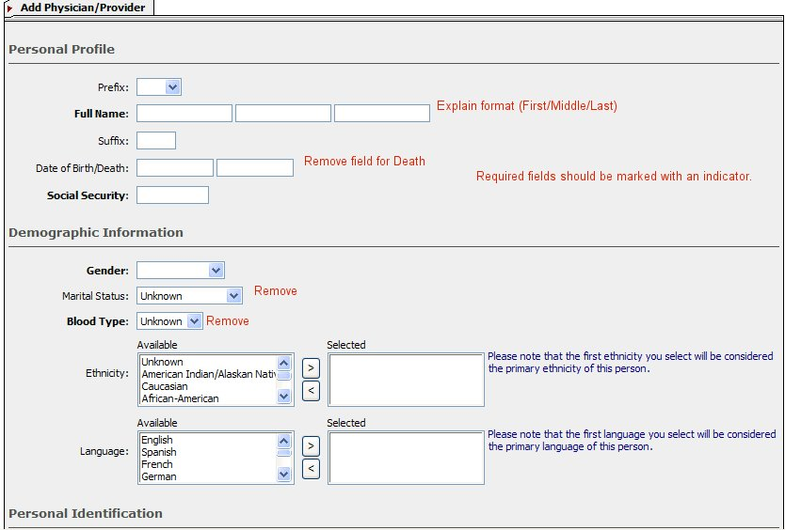
Fig 1a
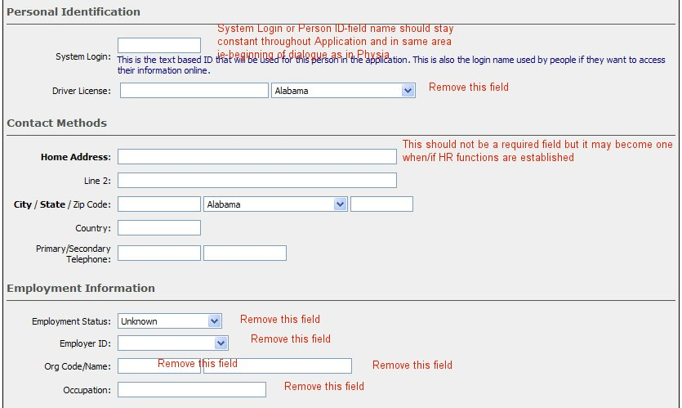
Fig 1b

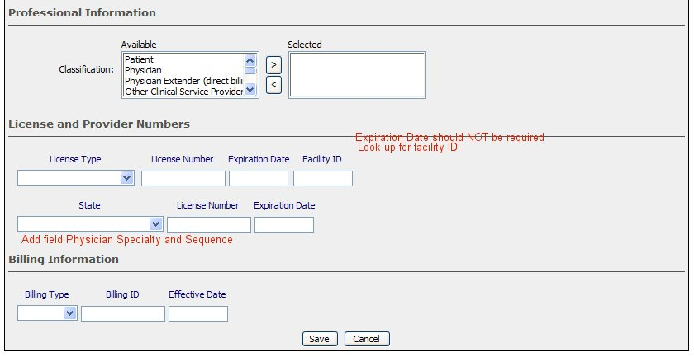
Fig 1c

Add:
- Explanation of Fields for Name (this should be consistent for all dialogues that request Person name). Fig 1a
- Markers indicating required fields (in Physia it is a red triangle). The following should be required: Name, Date of Birth, Billing Type, Gender and Classification. Fig 1a, 1c
- Add Look ups for Existing Physician and Facility ID (look up for Facility ID can be a drop down box that lists Associated Providers and Departments for the org.) Fig 1a, 1c
- Add field for Physician Specialty and Sequence. (See Example below)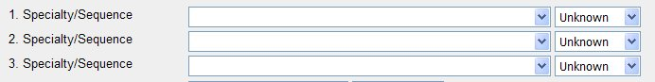
Fig 1d

- Add Next Action to Bottom of Screen next to Save/Cancel with the following fields: View Physician Summary/Add Another Physician/Go to Search/Return Home/Go to Work list

Remove:

- Field for Death
- Remove Marital Status
- Remove Blood Type
- Remove Drivers License
- Remove all of Employment Information from screen.

Edit:
- If possible, when user chooses other for ethnicity and/or language, the application offers a free text field.
- System Login moved to top or bottom of dialogue. (See document for action codes at Add-a-Patient to see notes on adding [Ok] next to 3 choices for system login.

Action Codes

Look up at Physician Name

Fig 1a
Look up an existing person: This lookup, whether an icon (magnifying glass or the words are a hyperlink) should take user to a search dialogue which allows the user to search for a person—see below. ***Note the method chosen for lookup should stay consistent throughout the application. **

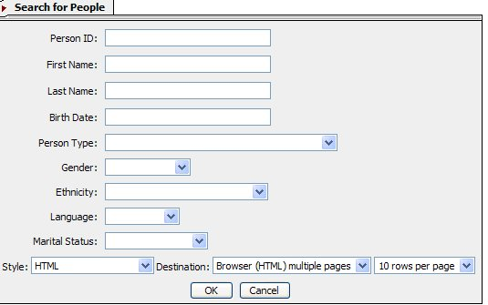

Fig 2a
This is a good search engine, because it is a search engine for all persons.

Add

- If birth date has to be in a certain format, then to the left of the Birth date box, should be a message stating the format (mmddyyyy). **Note: Anywhere in the application, where information should be entered in a certain format, there should be a small example of it near the field.

Once the user clicks OK, the system should pull up the results. See below. ***Note: Search results include all types of persons.

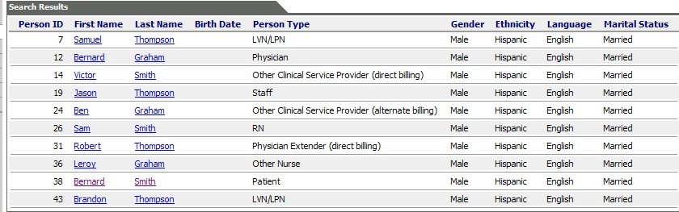
Fig 2b

Edit

- The hyperlink to the patient summary should be on the person ID.
- Switch Last Name column with First Name Column
- Sort in alphabetical order by Last Name.
- If a person is in several Person Types-either all types should be listed under the Person Type column or the person should have a row for each person type. (These will appear beneath each other since the persons will be listed alphabetically.)

Function

a) If a person is found in Org but not for Physician Person type, then the user should be able to click the Person ID (the hyperlink) and an additional dialogue should come up:
***If Patient ID hyperlinks to patient summary(as requested above) - can it also function to bring up the above dialogue? If not then can the name be made a hyperlink to summary page and Person ID made to be the link to above dialogue? *****

Do you want to add [Person_id] to Physician Type?→Yes→Dialogue for Add-a-Physician comes up with as much information as possible auto filled→User enters any additional information→User chooses Next Action→User clicks [Ok]→Application performs Next Action.
**See further down for descriptions on next action. **
Or

Do you want to add [Person_id] to Physician Type?→No→Application takes user back to blank Add-a-Physician Dialogue.

- If person is not found in the results of the search, the user should be able to close the search results and the application should take the user back to the blank “Add-a-Physician” dialogue.

Look up at Facility ID

Fig 1c
The choices in this field can be listed in a drop down as it is handled in Physia.

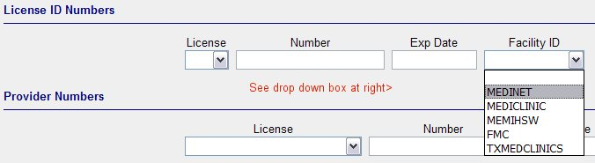
Fig 1e

The options listed are Associated Providers or Departments in the Main Org.

Next Action

Once the user completes all necessary fields in Add-a-Physician Dialogue, they should choose a Next Action (see below)

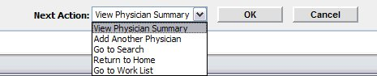
Fig 1f

View Physician Summary- should take user to physician Summary page
Add Another Physician-should take user to a blank Add-a-Physician Dialogue
Go to Search- should take user to Search for People Dialogue
Return to Home- should take user to their Home Page
Go to Work List- Should take user to Listing of Work List

Function:

User Clicks [OK] →Application suggests 3 Person Ids→Application should add an [OK] [Cancel] Button next to suggestions→User chooses Person Id→Clicks [OK]→ Application adds Person and performs Next Action.

